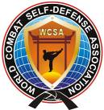

Official invitation for
INTERNATIONAL TOURNAMENT

COMBAT SELF-DEFENSE
“Black Sea–World Cup 2012”

men, women, juniors, cadets
SHADOW-FIGHTS, SELF-DEFENSE, ATTACK-TESTS, SAFE-POINT,
ММА: SAFE-COMBAT, LIGHT-COMBAT, FREE- COMBAT, MIX-COMBAT

WWW.COMBATSD.COM

ODESSA/UKRAINE, 2-8 July 2012

- DATE: 2th–8th July 2012. Arrival date of the foreign Tournament participants – July 1th-2th,
departure – July 9th-10 th.

- PLACE: Odessa (Ukraine) International Airport. Transfer to Koblevo (Hotel “Lotos”).

3) PROGRAM OF THE EVENT:

1-2 July - day of arrival;
2-3 July - judges seminars;
3-4 July - WEIGHT & PASSPORT CONTROL;
5-8 July - the competition of all martial arts styles, kinds, age and weight categories.
8 July at 19.00 - finals an Open Stadium in Odessa City;

9-10 July - the day of departure.

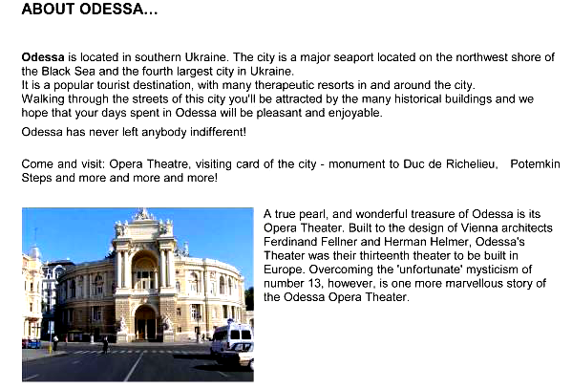

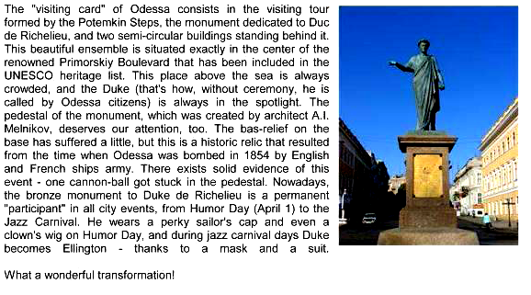
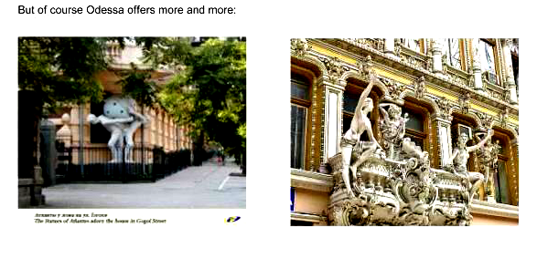

4) PROMOTER: Aleksandr Sosnin (Chairman and Technical Director of WCSA, 6-th Dan/Degree)

5) ORGANIZERS: World Combat Self-defense Association, International Combat Organisation.

6) WEIGHT & PASSPORT CONTROL: 3th-4th July 2012 (Koblevo-“Lotos”).

7) JUDGES AND REFEREES: Those who are interested in participation as judges and referees should inform, that they are going to attend a seminar. All Delegations are obligated to bring at least one (1) Judge or referee otherwise they will face a penalty. The seminar for judges will take place on July, 2th-3th to destination.

8) CONDITIONS FOR PARTICIPATION: Start of the fights: 5th July from 10.00 a.m. at Sport hall Complex “Lotos”. Allowed to start: Fighters of any styles and organizations, with a medical attestation. Each command should have at itself a national Hymn (on CD-disk) and the Flag.

Starting fees:
- €20 per participant, per division by June 2th, 2012.

Late Registration:
- €25 per participant, per division.
- athletic passport – 10 €. The fighter can participate in different disciplines.

In the absence of equipment will stand out in rent

9) ACCOMMODATION: Price Hotel 15-25 euro 1 day for person with breakfast and dinner.

Information: e-mail: wcombatsd@gmail.com; combatsd@mail.ru

10) DIVISIONS:

Shadow-fights
Attack-tests to12 years; 12-15 years; 16+ years
Self-defense

Winners and prize-winners of disciplines are awarded by a medal and the diploma, if in it not less than 4 participants.
10.1.1. Discipline – «Shadow Fights». Free demonstration of techniques of hands, feet and slopes (time of execution -- 30-60 seconds).
10.1.2. The discipline - "Self-defense" (the executor + the assistant () – is estimated only the executor. Time of execution from 1,5 till 3 minutes
10.1.3. Discipline – «Attack-Tests». Testing with the assistant (trainer) on paws, with blows by hands (1st round), feet (2nd round) in a combination to possible slopes and the waste techniques with the partner of a corresponding weight category (3rd round). Execution time 3 rounds for 20 seconds.
In the given section the sportsman and his instructor are estimated. (2 medals).
«Safe-Point»:

Equipment: a jacket and trousers (kimono), a helmet (type "safe"), protection of a shin and foot lifting, a groin protector. For girls the presence of a protector on a breast is necessary.
Fight lasts 90 seconds of pure time or to advantage in five points (gloves ММА or for hand-to-hand fight - And, In, About a class). Class D, Е - 60 seconds, gloves (4 + and 6 + ounces accordingly).
Class Years Weight, kg
Men | 18-40 | -60 | -68 | -77 | -86 | 86+
Women | 18-35 | -50 | -57 | 57+
Junior A-class (male) | 16-17 | -55 | -63 | -71 | -80 | 80+
Junior A-class (female) | 16-17 | -45 | -50 | -57 | 57+
Junior B-class (male) | 14-15 | -48 | -55 | -63 | -71 | 71+
Junior B-class (female) | 14-15 | -40 | -45 | -51 | 51+
Junior C-class (male) | 12-13 | -36 | -40 | -45 | -51 | 51+
Junior C-class (female) | 12-13 | -35 | -42 | 42+
Junior D-class (male) | 10-11 | -30 | -34 | -39 | -45 | 45+
Junior D-class (female) | 10-11 | -30 | -35 | -40 | 40+
Junior E-class (male) | 7-9 | -23 | -26 | -30 | -35 | 35+
Junior E-class (female) | 7-9 | -23 | -26 | -30 | 30+
Categories are considered full in the presence of 4 participants, otherwise
The credentials committee has the right to unite the next categories
(The difference in weight can't make more than 20 %)

«M M A»:

«Safe-Сombat»:

Equipment: a dense kimono, a helmet (type "safe"), gloves (for ММА or hand-to-hand fight), a groin protector. Fight lasts for adults 2 rounds for 2 minutes, A,B,C classes - 2 rounds for 1,5 minutes. Class D - 2 rounds for 1 minute, at class Е-2 of a round for 45 seconds.
Break between rounds for 30 seconds.
Any shock correct techniques in a rack, in a ground position attack by hands and feet at the torso, in a head only fixed blows by hands is resolved. Painful and suffocating receptions are resolved (on attempt 10 seconds) are given.

Class Years Weight, kg
Men | 18-35 | -56 | -60 | -65 | -71 | -78 |  | -86  -95 | +95
Woman | 18-35 | -50 | -55 | -60 | -65 | -70 | +70
Junior A-class (male) | 16-17 | -53 | -56 | -60 | - | 65  -71 | -78 | -86 | +86
Junior A-class (female) | 16-17 | -45 | -50 | -55 | -60 | +60
Junior B-class (male) | 14-15 | -45 | -50 | -55 | -60 | -65 | -70 | +70
Junior B-class (female) | 14-15 | -40 | -45 | -50 | -55 | +55
Junior C-class (male) | 12-13 | -35 | -40 | -45 | -50 | -55 | -60 | +60
Junior C-class (female) | 12-13 | -35 | -40 | -45 | +45
Junior D-class (male) | 10-11 | -30 | -34 | -39 | -45 | 45+
Junior D-class (female) | 10-11 | -30 | -34 | -39 | 39+
Junior E-class (male) | 7-9 | -23 | -26 | -30 | -35 | 35+
Junior E-class (female) | 7-9 | -23 | -26 | -30 | 30+
In all classes is used of a soft protector on a breast, at will, is supposed (Under a kimono).
For girls obligatory is used a protector in all age categories.
In classes E and D - obligatory use of a protector on a breast, and boxing gloves (4-6, 8-10 ounces accordingly).
In class D – the shock techniques in a ground position (the formula of fight 2 rounds for 1 minute) is forbidden
In class Е – ground position is prohibited (the formula of fight 2 rounds for 45 seconds).

«Light-Combat»

Equipment: a naked torso, shorts, a helmet (open type), gloves of open type (not less than 10 ounces, boxing gloves are supposed), protection of a shin and foot lifting, a groin protector, protection of teeth. For girls necessarily presence of a protector on a breast. Fight lasts 2 rounds for 2 minutes. Any is resolved shock and throw the correct techniques in a rack. In a head are resolved only supervised, dosed out, not the strong blows (Light). In a ground position only wrestling (10 seconds) against painful and suffocating receptions. The shock techniques in a ground position are forbidden!

Class Years Weight, kg
Junior B-class (male) | 14-15 | -45 | -50 | -55 | -60 | -65 | -70 | +70
Junior B-class (female) | 14-15 | -40 | -45 | -50 | -55 | +55
Junior C-clas | (male)  12-13 | -35 | -40 | -45 | -50 | -55 | -60 | +60
Junior C-class (female) | 12-13 | -35 | -40 | -45 | +45

«Free - Combat»

Equipment: a naked torso, shorts for the mixed single combats, an open helmet, protection of teeth, gloves opened with a soft filler (for hand-to-hand fight), the groin protector , a shin and foot lifting.
Fight lasts two rounds for 2 minutes, with a break for 30 seconds - adults, and a 2*1,5-A class (are possible 3 rounds of fight in the finals). Any is resolved shock and throw the correct techniques in a rack, in a ground position - painful and suffocating, having the instant continuation from a rack (to 10 seconds), blows in a ground position are forbidden.

Class Years Weight, kg
Men | 18-20 | -56 | -60 | -65 | -71 | -78 | -86 | -95 | 95+
Woman | 18-35 | -50 | -55 | -60 | -65 | -70 | +70
Junior A-class (male) | 16-17 | -53 | -56 | -60 | -65 | -71 | -78 | -86 | 86+
Junior A-class (female) | 16-17 | -45 | -50 | -55 | -60 | +60

«Mix-Combat»
Equipment: a naked torso, shorts for the mixed single combats, an open helmet, protection of teeth, gloves (ММА), the groin protector , a shin and foot lifting. Any shock correct techniques in a rack, throws, painful and suffocating receptions is resolved. Blows by hands and feet in a ground position at the torso, the limited quantity of blows by hands in a head (to 3 blows successively). The fight formula: 2 rounds for 3 minutes, the endings rounds for 3 minutes.
Class Years Weight, kg
Men | 18-35 | -56 | -60 | -65 | -71 | -78 | -86 | -95 | 95+

11) CONTACT: +7 9177619080 (Russia); +1 3474221131 (USA) - Aleksandr Sosnin

12) CONTACT – VISA DOCUMENTS:

For more Information or Visa Documents please contact:
e-mail: wcombatsd@gmail.ru
Visa is not required for citizens of the EU, the UK, the USA, Israel, Japan and some other countries. For further information contact the nearest consulate or embassy. http://www.mfa.gov.ua/mfa/en/publication/content/1865.htm

 | Registration form – “Black See Cup-2012”
 | Competitors
 | Name | Country/Club | M / F |  | Age |  | Weight |  | DD |  | SP |  | SC |  | LC |  | FC | MC
1
2
3
4
5
6
7
8
9
10
 | Coaches / Representatives
 | Name | Country/Club |  | coach/representative/…
1
2
3
4
5
 | Referees / Judges
 | Name | Country/Club
1
2
3
4
M / F = male or female
DD – Demo-Defense
SP – Safe-Point
SC – Safe-Combat
LC – Light-Combat
FC - Free-Combat
MC- Mix-Combat

Arrival & Departure Details
Country:……………………………………………………………………………………………………..
National Federation/Association's Name:………………………………………………………………………………………………….
Name of Representative:…………………….…………………………………….………………………..
Address:………………………………………………………………………………………………………………………………………………………
E-mail:…………………………………………………………………………………………………………
Telephone / Fax:…………………………………………………………………………..…………………
Flight Schedule:
Date of Arrival: …………………………… ………. Time of Arrival:…………………. …………………. No. of Persons:…………………………………… Flight No:…………………………………………… Airline Name:……………………………… …..…………………………………………………………….
Date of Departure: …………………………… ……Time of Departure:………………………………… No. of Persons:…………………………………… Flight No:…………………………………………… Airline Name:……………………………… …..…………………………………………………………….



